5.5 Surface Integrals

Motivation:
In section 5.2.1 we discussed the idea that a line integral was useful for adding up a quantity over a given curve C. In this section we wish to extend this idea to adding up a quantity over a given surface to create the idea of a surface integral.

This idea can be useful in a variety of applications
- Adding up charge across a magnetized surface.
- Adding up gravitational forces across a surface.
- Adding up the density across a surface to help find the mass of the surface.
- Adding up flow of fluid through to help find the total quantity of fluid flowing through .

So, how do we construct an integral that will do this?

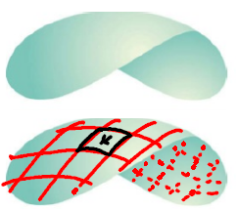
Exploration: Suppose we have a smooth surface that we plan to move across, and we want to add up the quantity at each point given by the function . Let Q represent the total quantity over the surface. How do we find Q?

We can begin by partition up into n patches.

Consider the k^{th} patch and

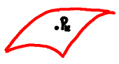

This leads us to the following definition.
Definition: Assuming that is continuous, the surface integral of f over the surface is .

Remark: Let be the parameterization of the surface . We saw in section 4.4 that the surface area of the k^{th} patch, , is approximated by .

Therefore, we can rewrite the previous definition as follows.
Definition (Updated): Assuming that is continuous, the surface integral of f over the surface is

Remark: Note that if , then the surface integral becomes which we know from section 4.4 yields the surface area of .

Example 1: Consider the surface .

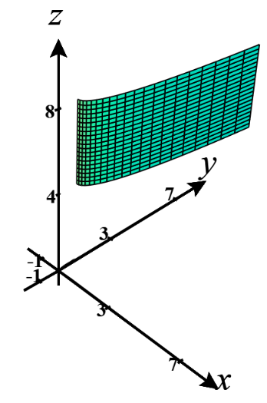
- Find a parameterization for .

- Evaluate .

Example 2: Compute the surface integral where is the unit sphere
Hint: Use what you know about spherical coordinates to find parametric equations for .
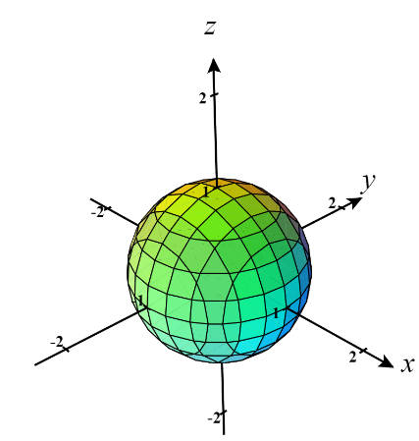

Example 3: Suppose is a smooth surface given by where . Express the surface integral as a double integral in terms of x and y.

Note: In this example we are assuming that f is continuous on . Oftentimes this condition is just assumed without being stated in the textbook.
The most recent example is the justification for the following formulas.

Formulas: Suppose is a smooth surface given by where . Then,
- A normal vector to the surface at is .

Note: It is possible to derive similar formulas in the cases where the surface is given by or when the surface is given by . Can you guess what the formulas would be in these cases? See page 1133 of the book for one of the formulas.

Example 4: Fully setup, but do not evaluate, the surface integral where is the portion of the surface which exists over the triangular region with endpoints .

We now state a fact which we will recognize as an extension of a property of line integrals.

Fact: If is a finite union of smooth surfaces: (we say is piecewise-smooth), then

.

Example 5: Suppose that is the “can without a top” which consists of and .

- Find a parameterization of .

- Find a parameterization of .

- Evaluate .

- Note that didn’t need to be parameterized and could have just been expressed as the surface in the form of over a region D. Find the surface integral for using this approach.

